Problem 1:

Given, P(s) = $\frac{K}{Ts+1}$; C(s) = $K_{p}+\frac{K_{i}}{s^{α}}+K_{d}s^{β}$;

where K = 0.55, T = 62, α = 0.1578, β = 1.0148, $K_{i}$ = 98.11268, $K_{p }$ = 15.2864, $K_{d }$ = 1.1625

C(s) = $K_{p}+\frac{K_{i}}{s^{α}}+K_{p}s^{β}$ = $K_{p}$ (1 + $\frac{K_{i}}{s^{α}}$ + $K_{d}s^{β}$) = $K_{p}K_{d}$ ( $s^{α+β}+ \frac{s^{α}}{K_{d}}$ + $\frac{K_{i}}{K_{d}}$) ($\frac{1}{s^{α}}$)

L(s) = P(S)C(s)

= ( $\frac{K}{Ts+1})$ ${(K}_{p}) \left(K_{d}\right)$ ( $s^{α+β}+ \frac{s^{α}}{K_{d}}$ + $\frac{K_{i}}{K_{d}}$) ($\frac{1}{s^{α}}$)

Putting the given values

L(s) = ($\frac{0.55}{62s+1}$) $(15.2864) \left(1.1625\right)$ ( $s^{0.1578 +1.0148}+ \frac{s^{0.1578}}{1.1625}$ + $\frac{98.11268}{1.1625}$) ($\frac{1}{s^{0.1578}}$)

Now separating all the basic terms from L(s) = ( $\frac{K}{Ts+1})$ ${(K}_{p}) \left(K_{d}\right)$ ( $s^{α+β}+ \frac{s^{α}}{K_{d}}$ + $\frac{K_{i}}{K_{d}}$) ($\frac{1}{s^{α}}$), the asymptotic calculation of ($\frac{K}{Ts+1})$, ${(K}_{p}), \left(K_{d}\right),$ ( $s^{α+β}+ \frac{s^{α}}{K_{d}}$ + $\frac{K_{i}}{K_{d}}$) and ($\frac{1}{s^{α}}$), is shown below

1. For , |T(jω)| = 20log ($K_{p}$)

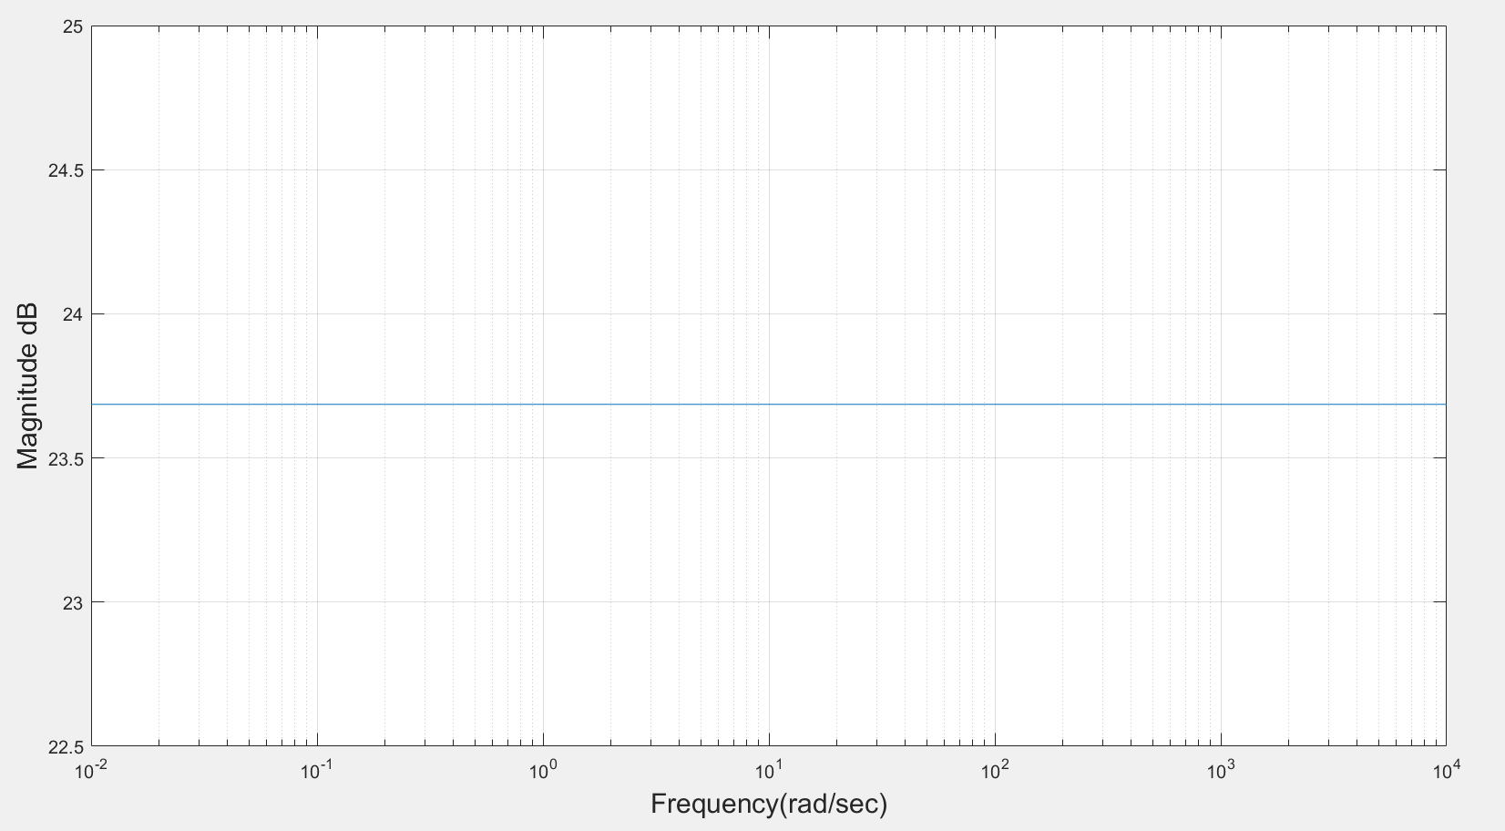

Figure 1: Asymptotic magnitude bode plot for constant gain, $K_{p}$

1. For , |T(jω)| = 20log ($K_{d}$)

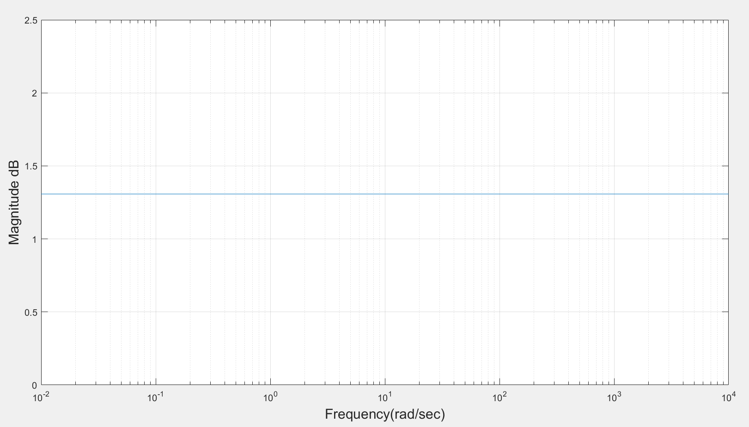

Figure 2: Asymptotic magnitude bode plot for constant gain, $K_{d}$

1. For K, |T(jω)| = 20log (K)

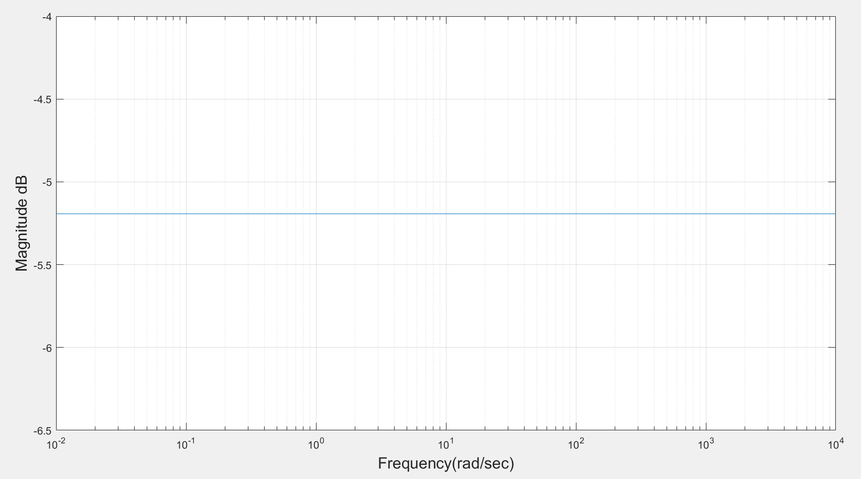

Figure 3: Asymptotic magnitude bode plot for constant gain, K

1. For ( $s^{α+β}+ \frac{s^{α}}{K_{d}}$ + $\frac{K_{i}}{K_{d}}$),

T(s) = ( $s^{α+β}+ \frac{s^{α}}{K_{d}}$ + $\frac{K_{i}}{K_{d}}$) ……….. (1)

Put s = jω, in equation (1) results into T(s) = {( ${jω)}^{α+β}+ \frac{{(jω)}^{α}}{K_{d}}$ + $\frac{K_{i}}{K_{d}}$}……. (2)

**Calculation procedure**

$({jω)}^{α+β}$**= $j^{α+β}.ω^{α+β}$.**

= $({0+1j)}^{α+β}$. $ω^{α+β}$ = ${\text{(cos}\frac{π}{2}+j\text{sin }\frac{π}{2}\text{)} }^{α+β}$. $ω^{α+β}$

Applying De Moivre’s theorem in above equation we get

$=\text{(cos}\frac{(α+β)π}{2}+j\text{sin }\frac{(α+β)π}{2}\text{)}$. $ω^{α+β}$…… (3)

Again, $({jω)}^{α}$ = ${\text{(cos}\frac{π}{2}+j\text{sin }\frac{π}{2}\text{)} }^{α}$. $ω^{α}$…… (4)

Put equation (3) and (4) in (2) we get

T(jω) = ${(ω}^{α+β}$ $\text{cos}\frac{(α+β)π}{2}$ + j $ω^{α+β}\text{s}in\frac{(α+β)π}{2}$) + ( $ω^{α}\frac{1}{K_{d}}$ $\text{cos}\frac{απ}{2}$ + j $ω^{α}\frac{1}{K_{d}}\text{s}in\frac{απ}{2}$) + $\frac{K_{i}}{K_{d}}$

= ${(ω}^{α+β}$ $\text{cos}\frac{(α+β)π}{2}$ + $ω^{α}\frac{1}{K_{d}}$ $\text{cos}\frac{απ}{2} + \frac{K_{i}}{K_{d}}$) + (j $ω^{α+β}\text{s}in\frac{(α+β)π}{2}$ + j $ω^{α}\frac{1}{K_{d}}\text{s}in\frac{απ}{2}$)

Magnitude,

|T(jω) | =

=

=

Magnitude in dB |T(jω) | dB = 20log ${{\{ω}^{2(α+β)} + ω^{2α}\frac{1}{{K_{d}}^{2}} + { ( \frac{K_{i}}{K_{d}} )}^{2} + 2\frac{1}{K_{d}}ω^{2α+β} cos\frac{βπ}{2} + 2\frac{1}{K_{d}}\frac{K_{i}}{K_{d}}ω^{α} cos\frac{απ}{2} + 2\frac{K_{i}}{K_{d}}ω^{α+β}cos\frac{\left(α+β\right)π}{2}\}}^{\frac{1}{2}}$

In the sum ${\{ω}^{2(α+β)} + ω^{2α}\frac{1}{{K_{d}}^{2}} + { ( \frac{K_{i}}{K_{d}} )}^{2} + 2\frac{1}{K_{d}}ω^{2α+β} cos\frac{βπ}{2} + 2\frac{1}{K_{d}}\frac{K_{i}}{K_{d}}ω^{α} cos\frac{απ}{2} + 2\frac{K_{i}}{K_{d}}ω^{α+β}cos\frac{\left(α+β\right)π}{2}$, ${ ( \frac{K_{i}}{K_{d}} )}^{2}$ dominates at lower frequencies whereas $ω^{2(α+β)}$ dominates at higher frequencies. For approximation we consider ${ ( \frac{K_{i}}{K_{d}} )}^{2}$ = $ω^{2(α+β)} |_{ω=ω_{cr}}$. Now, we obtain corner frequency, $ω_{cr}$ = ${|\frac{K_{i}}{K_{d}}|}^{\frac{1}{α+β}}$.

Following approximation of magnitude is obtained:

1. For ω ≤ , |T(jω) | dB = 20log||.
2. For ω >, |T(jω) | dB = 20(α+β) log ω.

**Procedure**

* Compute the corner frequency $ω_{cr}$ = ${|\frac{K_{i}}{K_{d}}|}^{\frac{1}{α+β}}$ and locate the point at magnitude

20log| |.

* Draw a slope 0 dB/decade for ω ≤ $ω_{cr}$ and a line with slope 20(α+β) dB/decade for

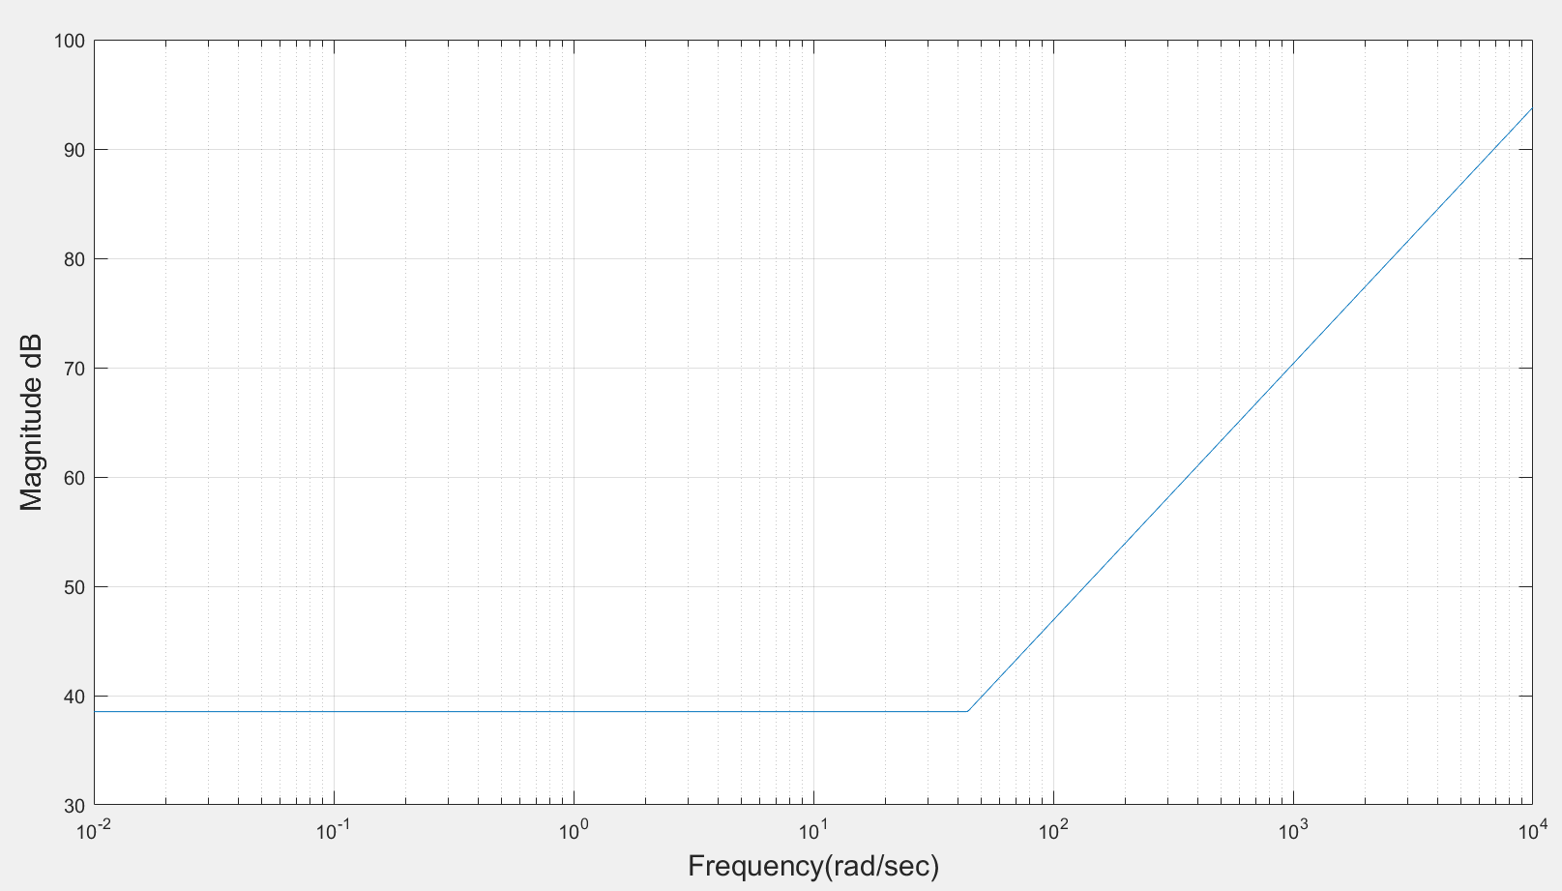

Figure 4: Asymptotic magnitude bode plot for ( $s^{α+β}+ \frac{s^{α}}{K_{d}}$ + $\frac{K_{i}}{K_{d}}$)

1. For, $\frac{1}{s^{α}}$

Fractional zero transfer function is given by T(s) = $\frac{1}{s^{α}}…$…… (1)

Put s = jω, in equation (1) results into T(jω) = $\frac{1}{{jω}^{α}}$……. (2)

Magnitude in dB is given by |T(jω)| dB= -20αlogω

**Calculation procedure**

$({jω)}^{α}$ = $({0+1j)}^{α}$ = ${ \text{(cos}\frac{π}{2}+j\text{sin }\frac{π}{2}\text{)} }^{α}ω^{α}$

Applying De Moivre’s theorem in above equation we get

= $\text{(cos}\frac{απ}{2}+j\text{sin }\frac{απ}{2}\text{)}$. $ω^{α}$…… (3)

Put equation (3) in (2) we get

T(jω) = $\frac{1}{ω^{α}.cos\frac{απ}{2} + jω^{α}sin \frac{απ}{2}}$

Magnitude, |T(jω) | = =

Magnitude in dB is given by |T(jω) | dB= -20αlogω.

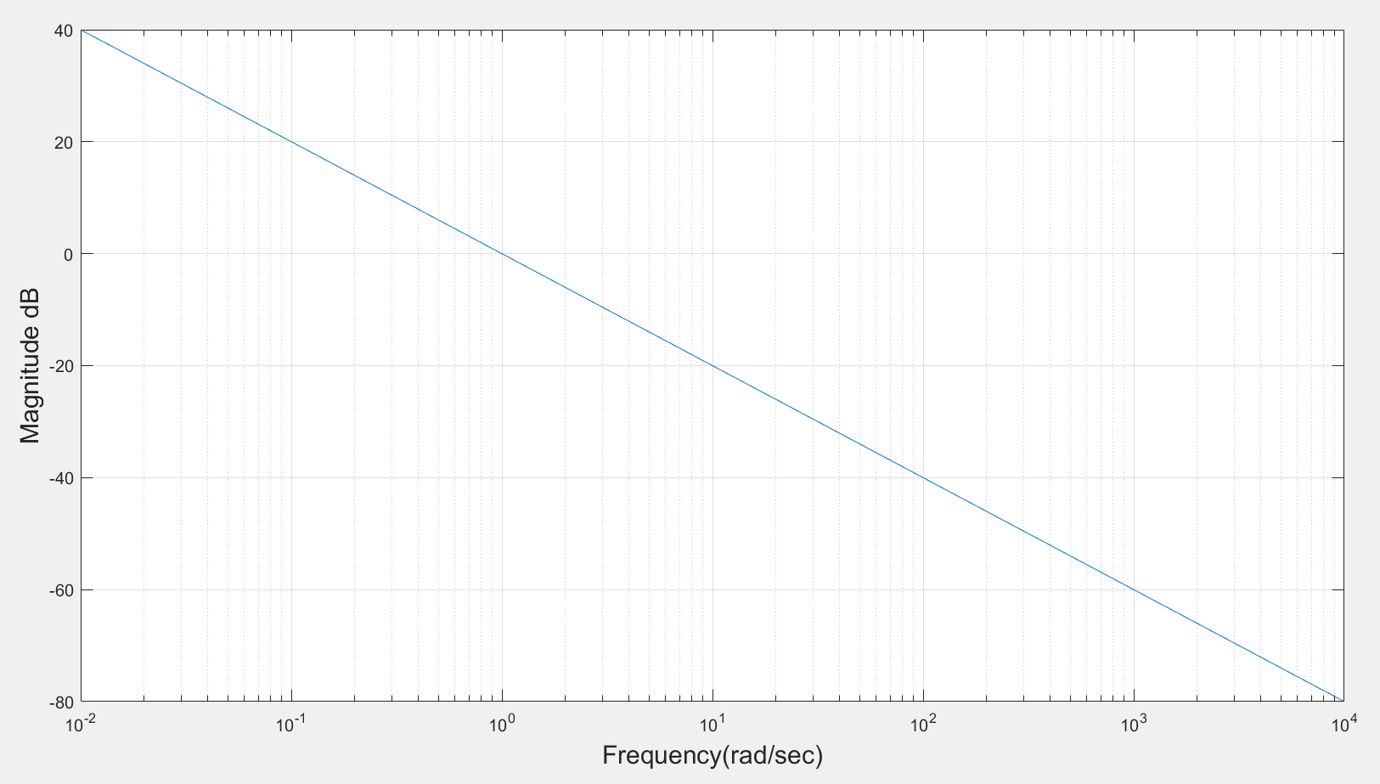Figure 5: Asymptotic magnitude bode plot for $\frac{1}{s^{α}}$

1. For $\frac{1}{Ts+1}$, putting T = 62

T(s) = $\frac{1}{62s+1}$ now put s=jω

T(jω) = $\frac{1}{62jω+1}$--------(a)

Now,

$(jω)$ = $\left(0+1j\right)$ = $\left(\text{cos}\frac{π}{2}+j\text{sin }\frac{π}{2}\right)ω$………. (b)

Putting (b) in (a)

T(jω) = $\frac{1}{62(ωcos\frac{π}{2} +jωsin \frac{π}{2}) +1}$ = $\frac{1}{\left(62ωcos\frac{π}{2}+1\right)+ j62ωsin \frac{π}{2}}$

Magnitude, |T(jω) | =

=

=

Now, Magnitude in dB, |T(jω) | dB = -20log ${\text{(}{{62}^{2}ω}^{2} \text{+ }1 \text{+ }124ω\text{cos}\frac{π}{2}\text{)}}^{\frac{1}{2}}$

In the sum ${{62}^{2}ω}^{2} \text{+ }1 \text{+ }124ω\text{cos}\frac{π}{2}$, $1^{2}$ dominates at lower frequencies whereas ${{62}^{2}ω}^{2}$ dominates at higher frequencies.

For approximation we consider $1^{2}$ = ${62}^{2}ω^{2}|_{ω=ω_{cr}}$.We obtain corner frequency, $ω_{cr}$ = $|\frac{1}{62}|$.

Now, following approximation of magnitude is obtained:

1. For ω ≤ , |T(jω) | dB = -20log ${(1^{2})}^{\frac{1}{2}}$ = -20log|1|.
2. For ω >, |T(jω) | dB = -20log ${(0.16.ω^{2α})}^{\frac{1}{2}}$ = -20log ($62ω$)

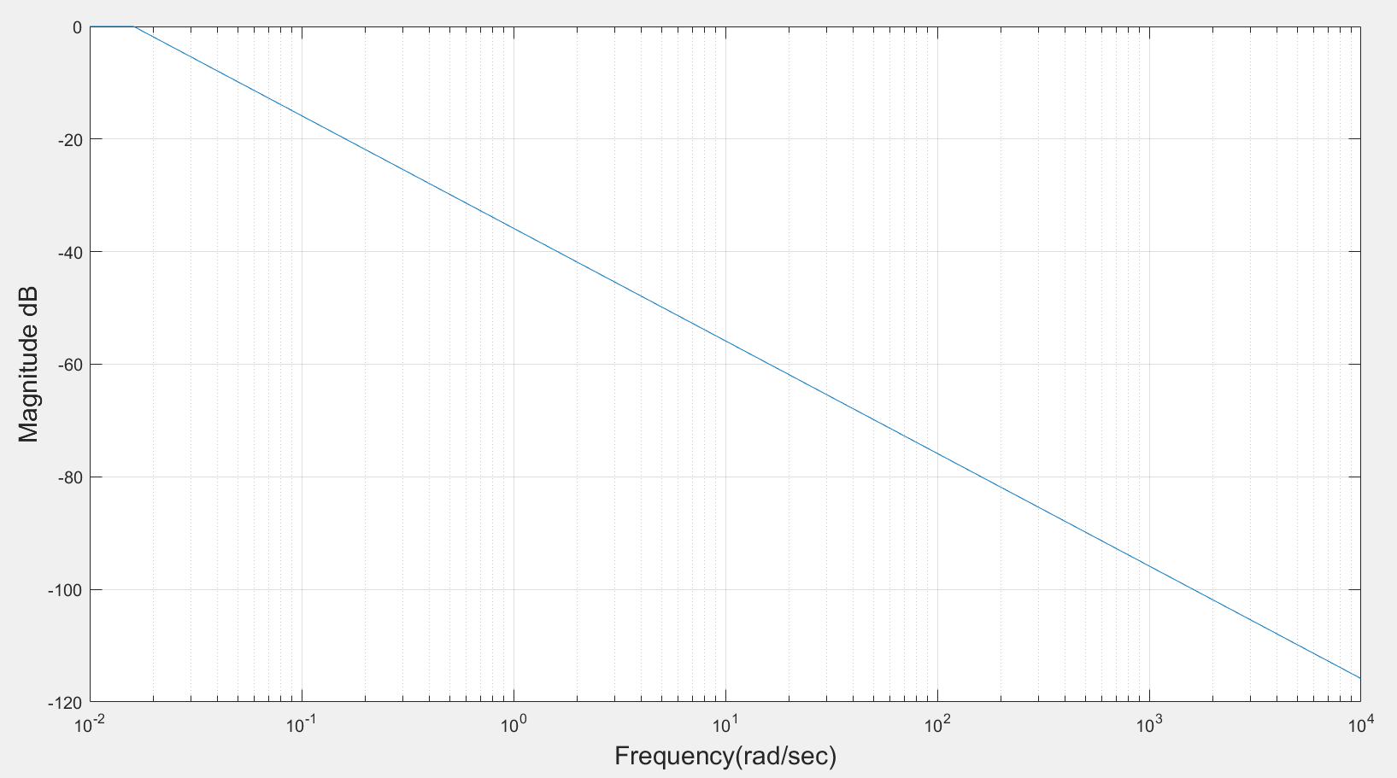

Figure 6: Asymptotic magnitude bode plot for $\frac{1}{Ts+1}$

1. L(s) is composed of basic terms, by adding the asymptotic plot of ($\frac{K}{Ts+1})$, ${(K}_{p}), \left(K_{d}\right),$ ( $s^{α+β}+ \frac{s^{α}}{K_{d}}$ + $\frac{K_{i}}{K_{d}}$) and ($\frac{1}{s^{α}} )$ one can find asymptotic plot for L(s)

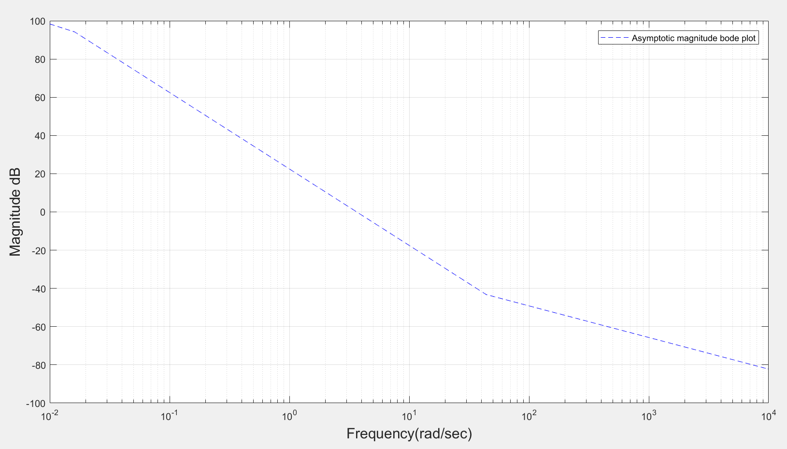

Figure 7: Asymptotic magnitude bode plot for L(s)

1. For exact magnitude bode plot of L(s)

L(s) = P(S)C(s)

= ( $\frac{K}{Ts+1})$ ${(K}_{p}) \left(K_{d}\right)$ ( $s^{α+β}+ \frac{s^{α}}{K_{d}}$ + $\frac{K_{i}}{K_{d}}$) ($\frac{1}{s^{α}}$)

Now,

Magnitude, |L(jω)| = 20log{$(\frac{K}{Ts+1}) {(K}_{p}) \left(K_{d}\right) (s^{α+β}+ \frac{s^{α}}{K_{d}} + \frac{K_{i}}{K_{d}} ) ( \frac{1}{s^{α}} )\}^{\frac{1}{2}}$

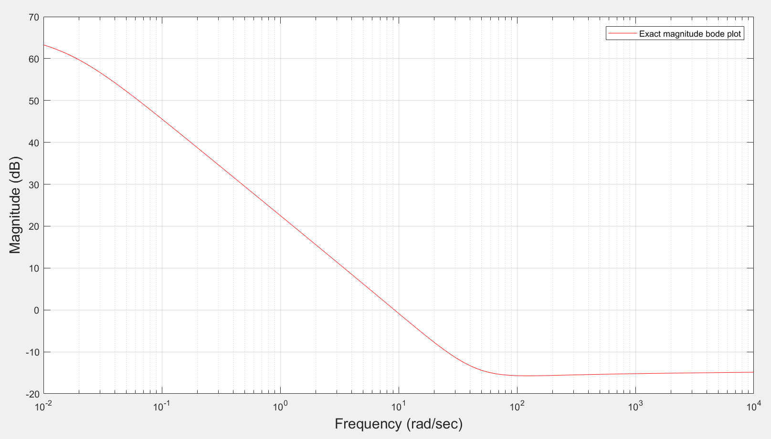

Figure 8: Exact magnitude bode plot for L(s)

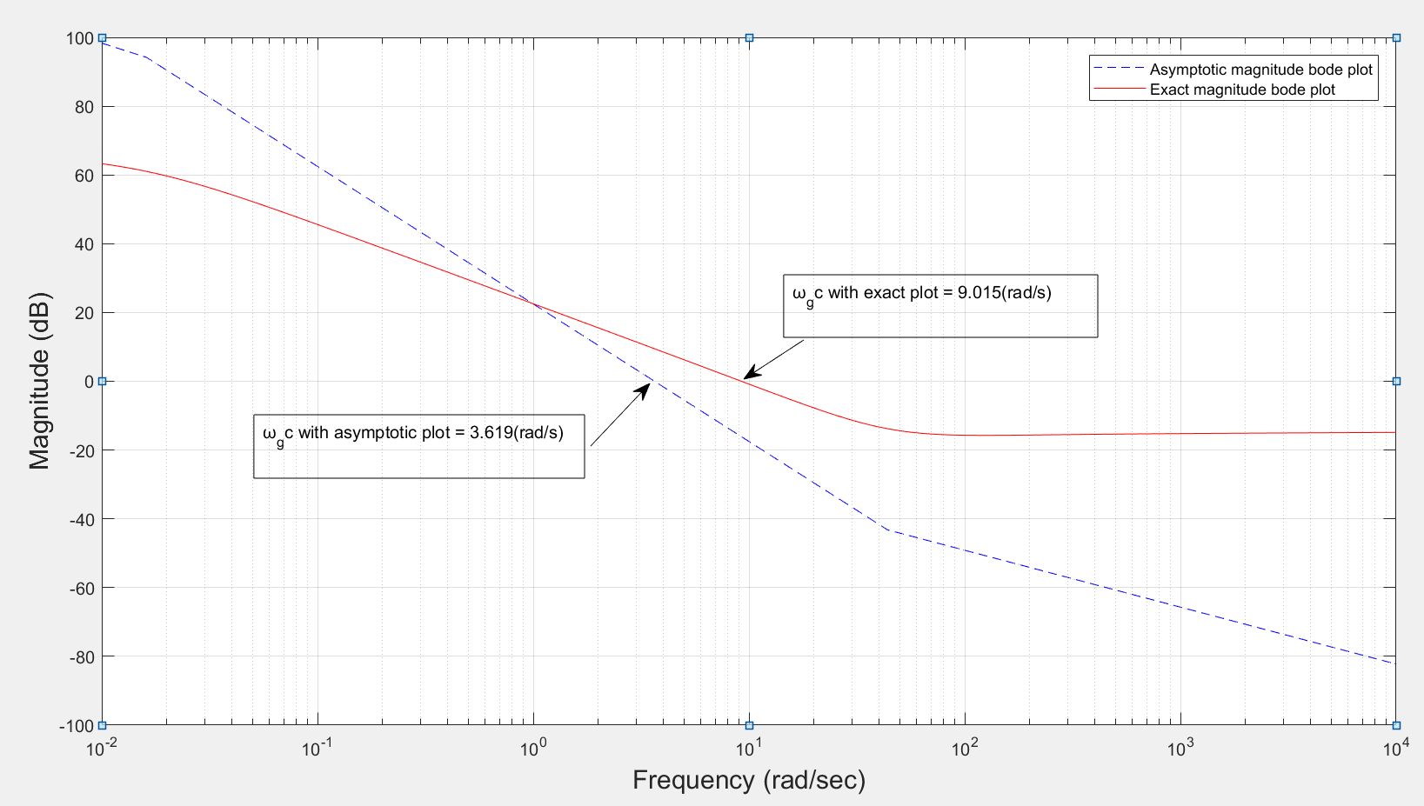

Fig 9: Real and asymptotic magnitude bode plot for L(s)

From fig 9, $ω_{gc}$ is obtained as

1. $ω_{gc}$ for asymptotic = 3.619(rad/sec)
2. $ω_{gc}$ for exact plot = 9.015(rad/sec)

**Matlab**

clc;

clf;

clear all;

close all;

Kp = 15.2864;

Ki = 98.1268;

Kd = 1.1625;

alpha = 0.1578;

beta = 1.0148;

K= 0.55;

T = 62;

Wcr = (abs(Ki/Kd))^(1/(alpha + beta));

Wcr1 = (abs(1/62));

w = logspace(-2 , 4, 1000);

mask = w < Wcr;

mask1 = w < Wcr1

mag1 = 20*log10(Kp)*ones(size(w));

mag2 = 20*log10(Kd)*ones(size(w));

mag3 = 20*log10(K)*ones(size(w));

mag4 = (mask).*(20*log10(Ki/Kd)) + (~mask).*(20*(alpha + beta)*log10(w));

mag5 = -20*log10(w);

mag6 = (mask1).*(-20*log10(1)) + (~mask1).*(-20*log10(62*w));

combined = mag1 + mag2 + mag3 + mag4 + mag5 + mag6 ;

figure(1);

plot(1,1);

semilogx(w, mag1)

xlabel('Frequency(rad/sec)','FontSize', 15);

ylabel('Magnitude dB','FontSize', 15);

grid on;

figure(2);

plot(1,2);

semilogx(w, mag2)

xlabel('Frequency(rad/sec)','FontSize', 15);

ylabel('Magnitude dB','FontSize', 15);

grid on;

figure(3);

plot(1,3);

semilogx(w, mag3)

xlabel('Frequency(rad/sec)','FontSize', 15);

ylabel('Magnitude dB','FontSize', 15);

grid on;

figure (4);

plot(1,4);

semilogx(w, mag4)

xlabel('Frequency(rad/sec)','FontSize', 15);

ylabel('Magnitude dB','FontSize', 15);

grid on;

figure (5);

plot(1,5);

semilogx(w, mag5)

xlabel('Frequency(rad/sec)','FontSize', 15);

ylabel('Magnitude dB','FontSize', 15);

grid on;

figure (6);

plot(1,6);

semilogx(w, mag6)

xlabel('Frequency(rad/sec)','FontSize', 15);

ylabel('Magnitude dB','FontSize', 15);

grid on;

figure(7);

plot(1,7);

semilogx(w, combined,'Color','blue','LineStyle','--')

xlabel('Frequency(rad/sec)','FontSize', 15);

ylabel('Magnitude dB','FontSize', 15);

grid on;

legend('Asymptotic magnitude bode plot','Location','NorthEast')

plot(1,1);

semilogx(w, combined,'Color','blue','LineStyle','--')

xlabel('Frequency(rad/sec)','FontSize', 15);

ylabel('Magnitude dB','FontSize', 15);

grid on;

hold on;

clc;

clear

Kp = 15.2864;

Ki = 98.1268;

Kd = 1.1625;

alpha = 0.1578;

beta = 1.0148;

K= 0.55;

T = 62;

w=logspace(-2,4,1000);

Mag=@(w) (20*log10(abs(sqrt(Kp).^2)) + 20*log10(abs(sqrt(Kd).^2)) + 20*log10(abs(sqrt(K).^2)) + 20*log10(abs(sqrt((i.*w).^(alpha+beta) + ((i.*w).^alpha)/Kd + (Ki/Kd)).^2)) - 20*log10(abs(sqrt((T*(i.*w)) + 1).^2)) - 20*log10(abs(sqrt(i*w).^alpha).^2));

semilogx(w,Mag(w) ,'Color','red');

hold on;

grid on;

xlabel('Frequency (rad/sec)','FontSize', 15);

ylabel('Magnitude (dB)','FontSize', 15);

legend('Asymptotic magnitude bode plot','Exact magnitude bode plot','Location','NorthEast')